**8. Obtén el número total de deportes jugados en cada juego olímpico**.

select Games, count(distinct sport) as Total_Juegos from athlete_events

group by Games;

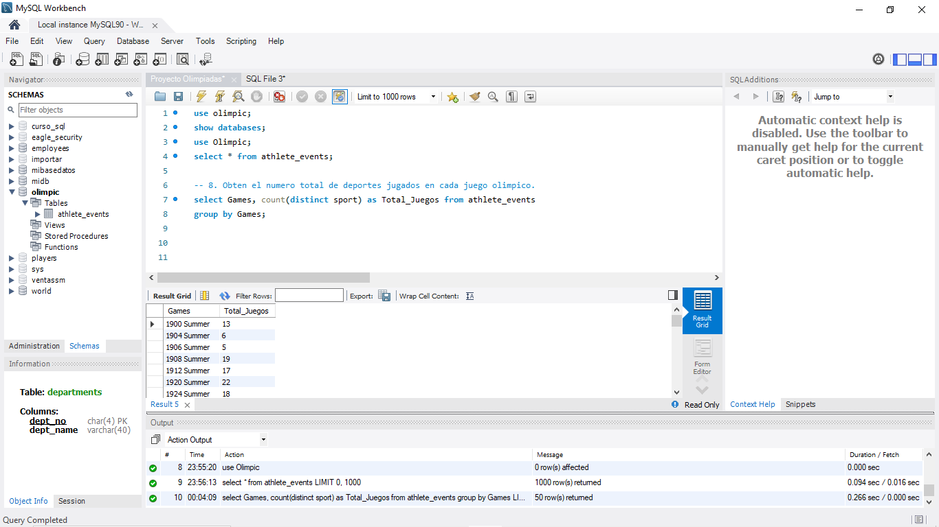

**9. Encuentre la proporción de atletas femeninos y masculinos que participaron en todos los juegos olímpicos.**

select * from athlete_events;

select Year,

round(MaleCount/TotalCount,2) as Male_Proportion,

round(FemaleCount/TotalCount,2) as Female_Proportion

From(

Select Year,

Count(*) as TotalCount,

sum(Case when sex='M' then 1 else 0 end) as MaleCount,

sum(Case when sex='F' then 1 else 0 end) as FemaleCount

from athlete_events

Group by Year) as sq1

order by Year;

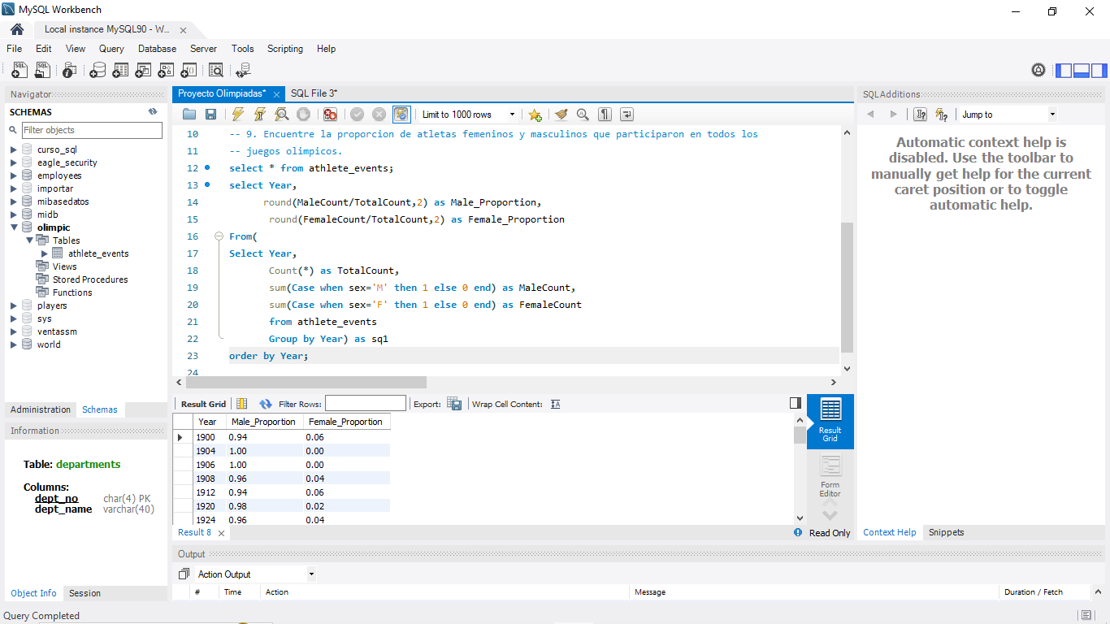

**10. Buscar los 5 mejores atletas que han ganado la mayor cantidad de medallas de oro**

select * from athlete_events;

create temporary table s1(select name, count(*) as Total_Medallas_Oro from athlete_events

where Medal='Gold'

group by name

order by Total_Medallas_Oro desc);

select * from s1;

select * from (select s1.*, dense_rank() over(order by s1.Total_Medallas_Oro desc) as DRK

from s1) as ranked

where DRK<=5;

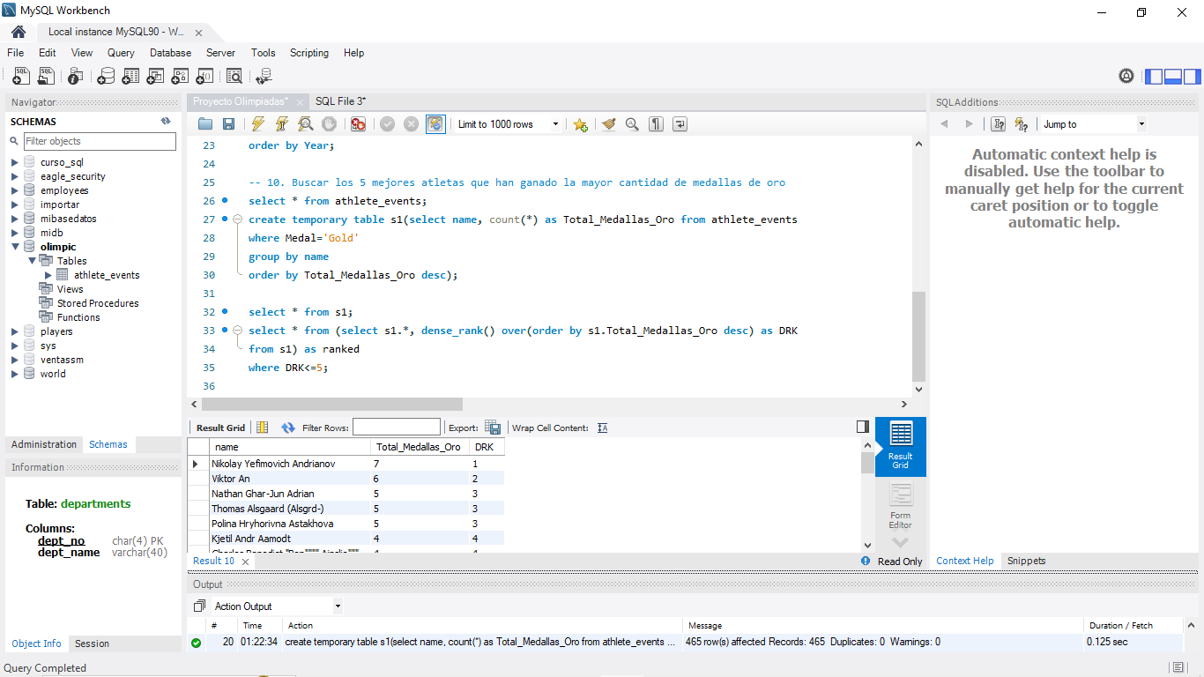

**11. Obtén los 5 mejores atletas que han ganado la mayoría de medallas (oro/plata/bronce)**

select name,

sum(case when Medal='Gold' then 1 else 0 end) as Gold,

sum(case when Medal='Silver' then 1 else 0 end) as Silver,

sum(case when Medal='Bronze' then 1 else 0 end) as Bronze,

count(*) as Total_Medals

from athlete_events

where Medal in('Gold', 'Silver', 'Bronze')

group by name

order by Total_Medals desc

limit 5;

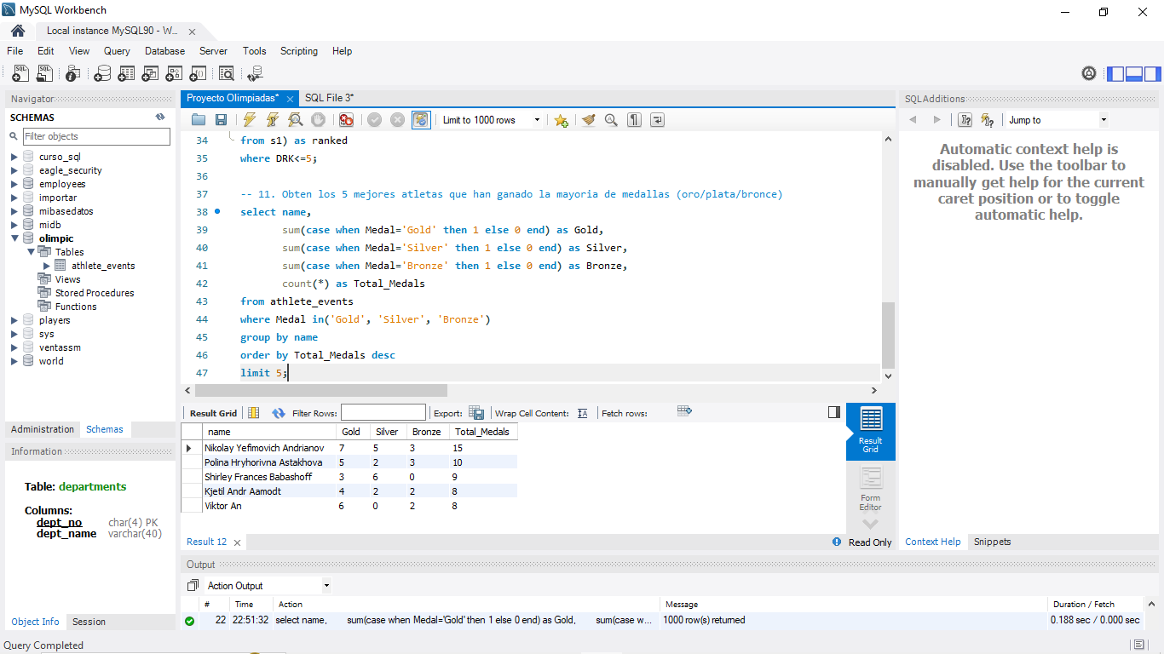

**12. Obtén los 5 países con más medallas ganadas en los juegos olímpicos**

select Team as Country,

sum(case when Medal='Gold' then 1 else 0 end) as Gold,

sum(case when Medal='Silver' then 1 else 0 end) as Silver,

sum(case when Medal='Bronze' then 1 else 0 end) as Bronze,

count(*) as Total_Medals

from athlete_events

where Medal in('Gold', 'Silver', 'Bronze')

group by Team

order by Total_Medals desc

limit 5;

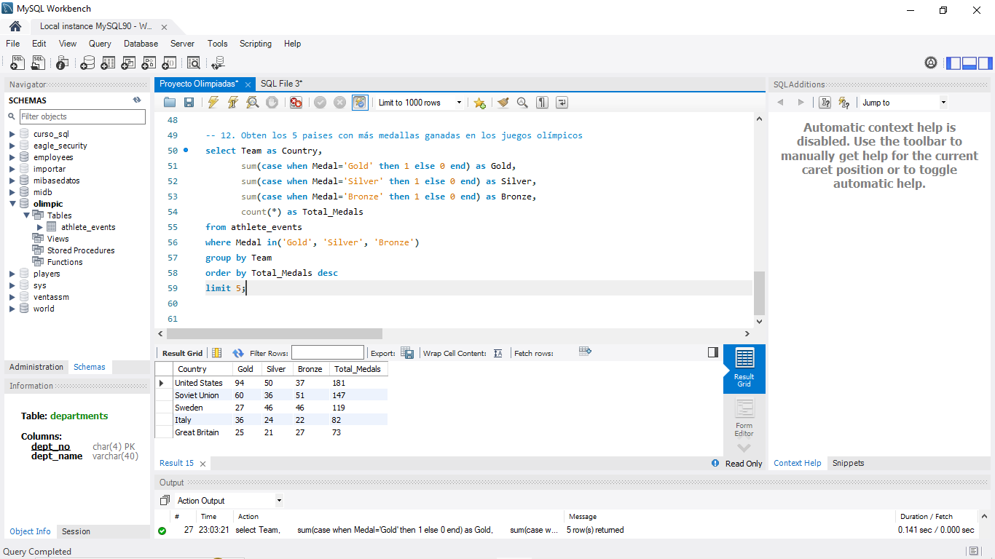

**13 Enumerar el total de medallas de oro, plata, bronce ganadas por cada país**

select Team as Country,

sum(case when Medal='Gold' then 1 else 0 end) as Gold,

sum(case when Medal='Silver' then 1 else 0 end) as Silver,

sum(case when Medal='Bronze' then 1 else 0 end) as Bronze,

count(*) as Total_Medals

from athlete_events

where Medal in('Gold', 'Silver', 'Bronze')

group by Team

order by Country;

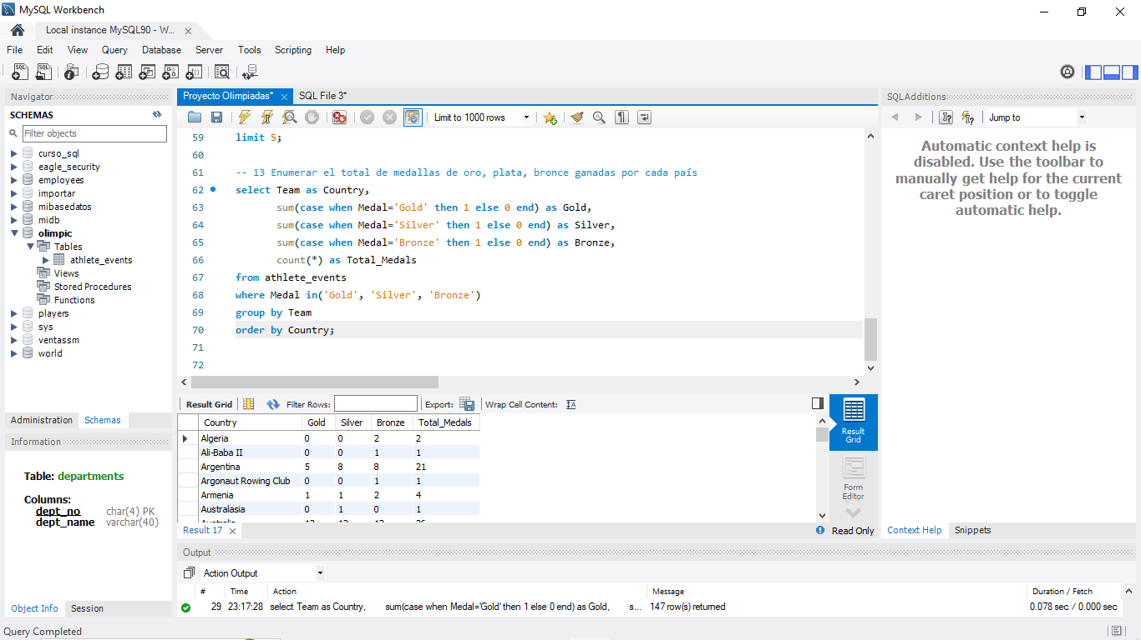

**14. Enumerar el número total de medallas de oro, plata, bronce ganadas por cada país en relación con cada juego olímpico**

select Team as Country, Year as Olimpic_Year,

sum(case when Medal='Gold' then 1 else 0 end) as Gold,

sum(case when Medal='Silver' then 1 else 0 end) as Silver,

sum(case when Medal='Bronze' then 1 else 0 end) as Bronze

from athlete_events

where Medal in('Gold', 'Silver', 'Bronze')

group by Team, Year

order by Country, Olimpic_Year;

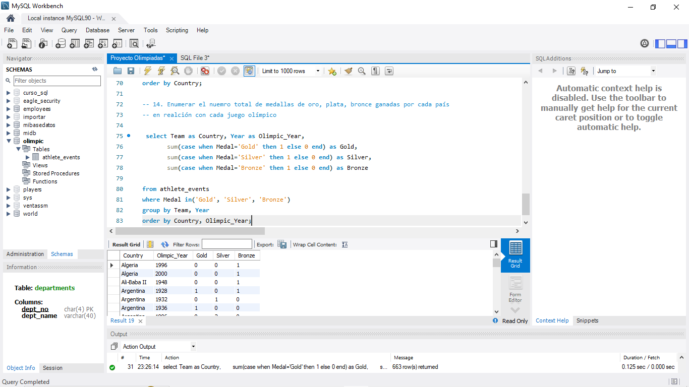

**15. Identifica que país ganó la mayoría de medallas de oro, plata, bronce en cada juego olímpico**

select Year,

Medal_Type,

Winning_Country,

Medal_Count,

Rank() over(partition by Year, Medal_type order by Medal_Count desc) as Country_Rank

from(

select Year, Team as Winning_Country, Medal, Count(*) as Medal_Count,

case

When Medal='Gold' then 'Gold'

When Medal='Silver' then 'Silver'

When Medal='Bronze' then 'Bronze'

end as Medal_Type

From athlete_events

where Medal in ('Gold', 'Silver', 'Bronze')

group by Year, Winning_Country, Medal) as MedalCounts;

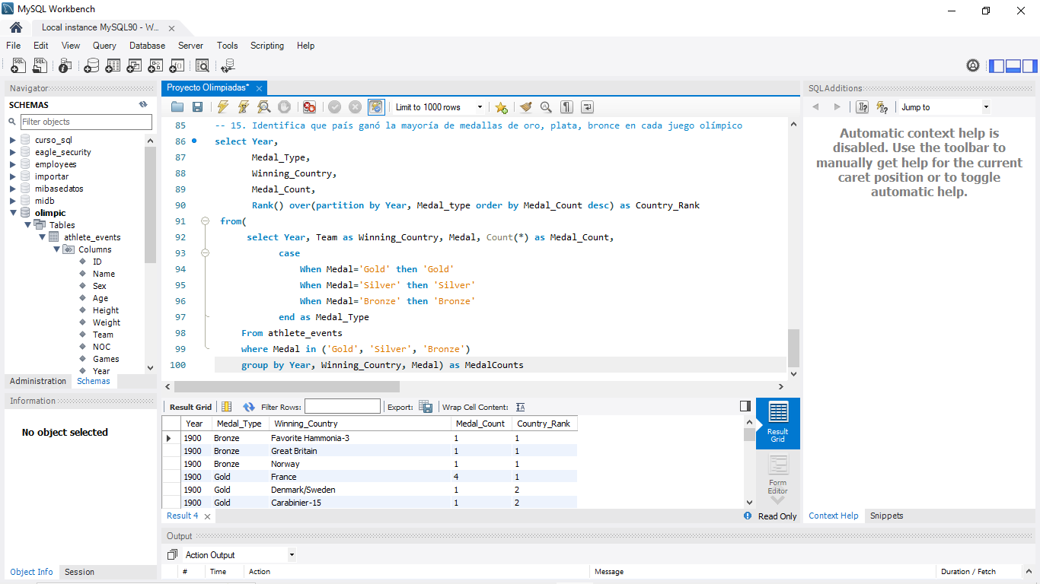

**16. ¿En qué deportes o eventos India ha ganado la mayor cantidad de medallas?**

select * from athlete_events;

select Sport,

Event,

sum(case when Medal='Gold' then 1 else 0 end) as Gold,

sum(case when Medal='Silver' then 1 else 0 end) as Silver,

sum(case when Medal='Bronze' then 1 else 0 end) as Bronze

from athlete_events

where Team='India' and Medal in ('Gold', 'Silver', 'Bronze')

group by Sport, Event

order by Gold desc, Silver desc, Bronze desc;

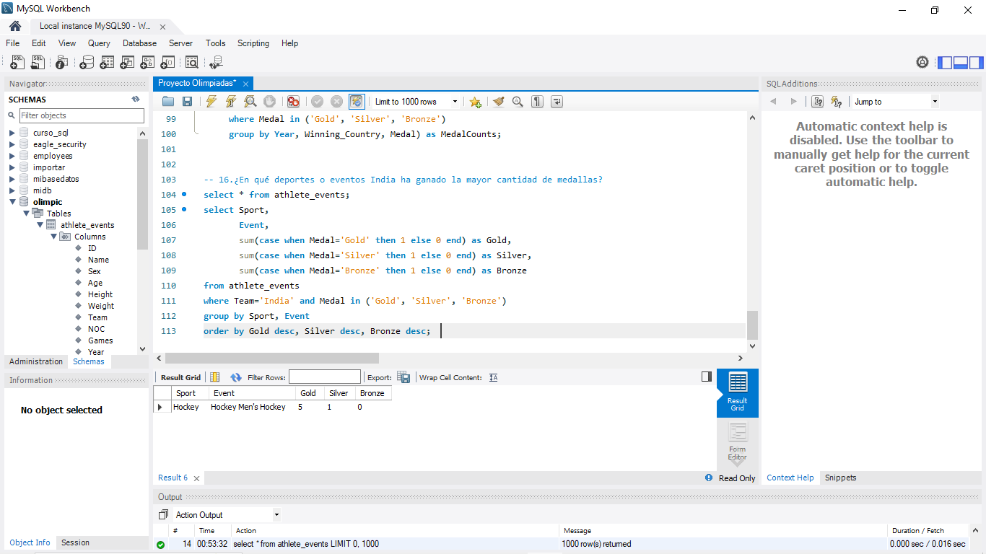

**17. Desglosa todos los juegos olímpicos en los que India ganó medallas en Hockey y cuantas medallas ganó en cada una de ellas**

select Year as Olympic_Year,

Count(*) as Total_Medal,

sum(case when Medal='Gold' then 1 else 0 end) as Gold,

sum(case when Medal='Silver' then 1 else 0 end) as Silver,

sum(case when Medal='Bronze' then 1 else 0 end) as Bronze

from athlete_events

where Team='India' and Medal in ('Gold', 'Silver', 'Bronze') and Sport='Hockey'

group by Year

order by Olympic_Year;

